There are 7 team members in my team. 4 IS students and 3 CS students. During the period of release 1. All team members make contributions in the project according to their responsibilities.

I used to be the representative of the team 42 and made role specifications of team members. Considering of the hard work of coding, I and John joined the developer team and helped 3 CS students write codes. I and John used to study HTML, CSS, C#, C and SQL when we studied in China. So we joined the developer team and helped CS students release their work.

I am mainly responsible for the user interface of the application. This required me to design the UI first, then find some resources on the Internet, then write codes. During each team meeting held weekly, all team members came out with their ideas of UI. I recorded them and made them on the screen.

What’s more, as the project manager, I booked the meeting room and kept every team members in the loop, I also communicated with client team in order to meet client’s requirements. All team members kept updating user stories and release plans to make the project continue smoothly. During peer review, we shared our ideas of developer team’s application performance and let Mike and Averson to write the peer review letter. We use github, google drive and Wechat to share files and communicate instantly as well.

In release 1, the UI mainly includes 5 aspects, which are welcome page, homepage, upload page, register page and person profile page. Each aspect also includes several separate pages. I also found some free CSS and JavaScript code on the internet used to improve the performance of UI.

After finishing coding, I will do white box testing to make sure that the UI is good and connection between is good, as well as data refreshing. This is a very important and time-consuming task for me to debugging. So I need to throw myself into this task. During coding, I also need to change the UI synchronous, because my UI needs to cater to the team members’ requirements who were writing PHP code and SQL code.

Some screen shot of UI are placed below, with some brief descriptions. The source code of five aspects will be placed in my folder (Chris N9327754) in branch release 1 in github. Some CSS and JavaScript code will be placed in source code folder. If the tutor would like to see the whole performance of UI, please copy the html file with CSS and JavaScript in the same folder.

1. Welcome page

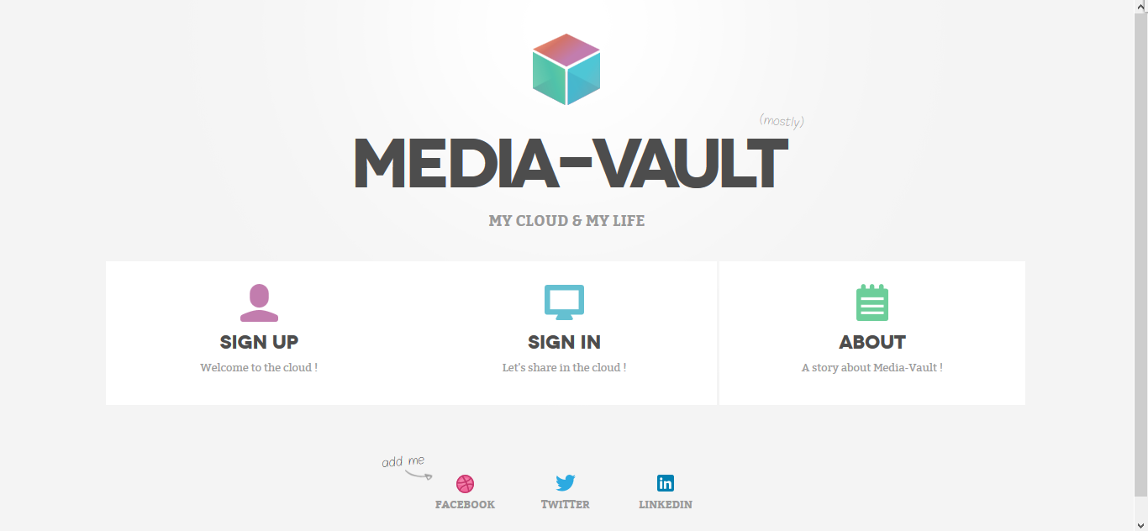

Description: This page is the welcome page for users to register and login. It also contains developers’ contact details.

1. Register and loin page

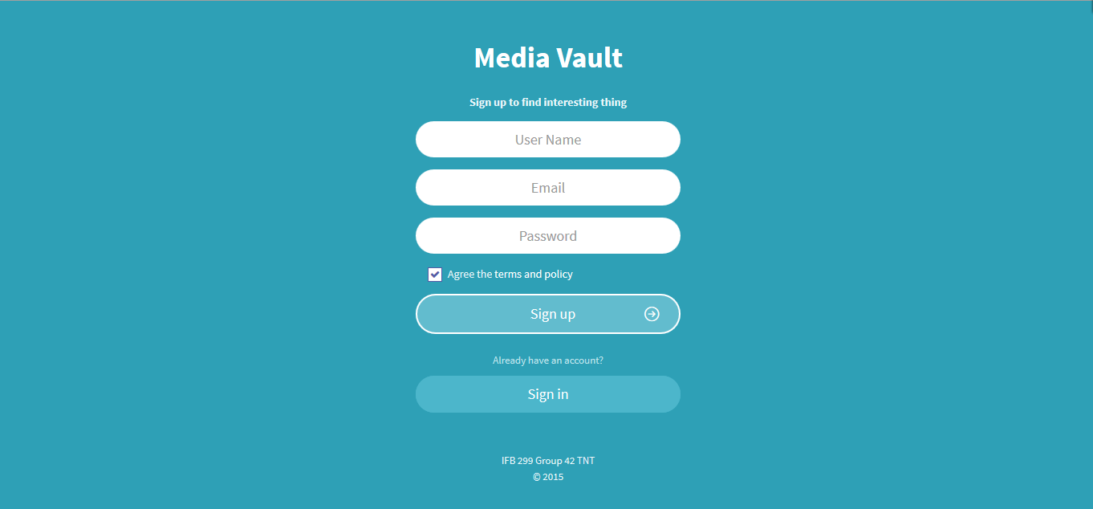

Description: This page is used for user to create account.

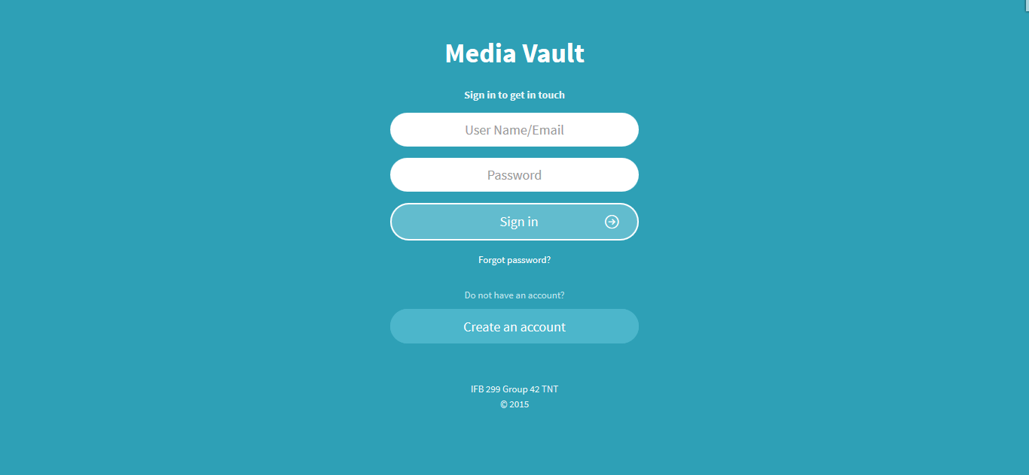

Description: This page is used for user to login.

1. Main page

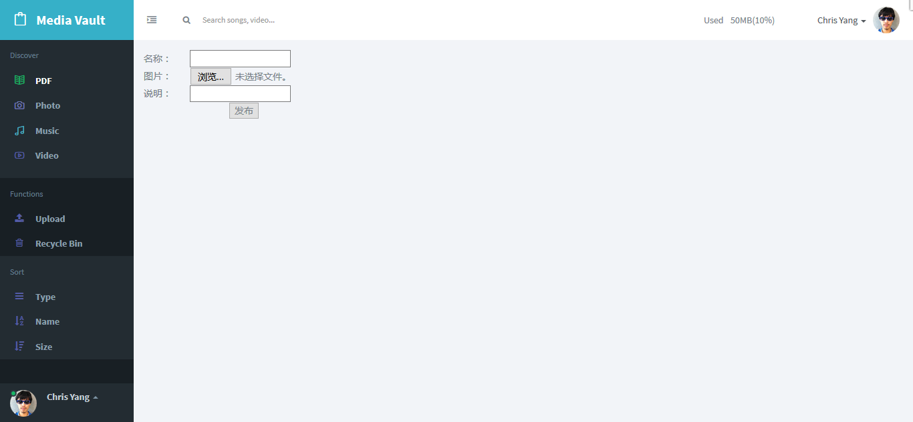

Description: There are five main pages of media vault, which are PDF, Photo, Music, Video and recycle bin. In order to maintain unification, all five pages have same left menu and top menu. The big white blank at the bottom right corner will show the detailed information of media files in each category.

Note:

1. The information in the big white blank is the test version.
2. Recycle bin, sorting function, storage capability function will be in release 2. They are not available in release 1.
3. Upload page

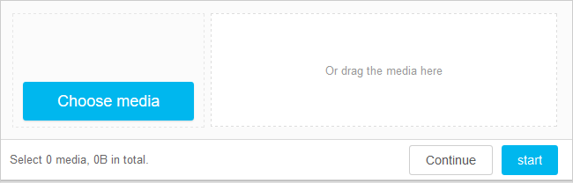

Description: This is the section for uploading

1. Personal profile

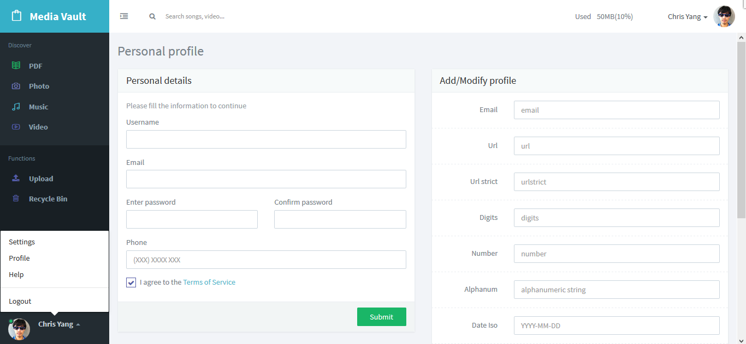

Description: This page is used for user to see and update personal details.

Notes:

1. This function is in release. It is not available in release 1.
2. This page is used for account setting and head photo uploading.
3. The information in the big white blank is the test version.